 Translated from Chinese (Simplified) to English - www.onlinedoctranslator.com

GRX04
Pulse enhanced open loop stepper driver

User Manual V1.0.0

Shenzhen Gerui IoT Technology Co., Ltd.
Table of contents
one,Product Introduction 4
1.1 Product Overview 4
1.2 Product Features 4
1.3 Application Areas 4
two,Electrical, Mechanical and Environmental Specifications 5
2.1 Mechanical installation diagram 5
2.2 Installation Notes 5
2.3 Electrical specifications 6
2.4 Operating environment and parameters 6
three,Driver interface and wiring introduction 6
3.1 Silkscreen Diagram 6
3.2 Interface Description 7
3.2.1 Control signal interface 7
3.2.2 Output signal interface 7
3.2.3 Motor control output interface 7
3.2.4 Power input interface 7
3.2.5 Status Indicator 8
3.3 Input control signal 8
3.3.1 Input control signal interface circuit 8
3.3.2 Control signal timing diagram 9
3.3.3 Control signal mode setting 9
3.4 Output control signal 9
3.4.1 Used as a brake control motor 9
3.5 Wiring requirements 10
Four,DIP switch function setting 10
4.1 Current Setting 10
4.2 Quiescent Current Setting 11
4.3 Segmentation Settings 11
4.4 Working mode setting 11
five,Power supply selection 12
six,Indicator lights and alarm indicators 13
seven,Warranty and after-sales 14
7.1 Warranty 14
7.1.1 Free warranty 14
7.1.2 Warranty exclusion 14
7.2 Exchange 14
7.2.1 Replacement of defective product 14
7.2.2 Exchange for non-product failure 15
7.3 Returns 15
7.4 After-sales service 15
eight,Revision History 16

Product Introduction

1.1 Product Overview
GRX04 Pulse Enhanced Open-Loop Stepper DriverIt is the latest product launched by Gerui IoT Technology Co., Ltd.EnhancementtypeOpen loop steppingDrive,ThatAdopt the latest dedicated motor control digital signal processor to improve the overall performance of the motor, reduce the heating level of the motor and reduce the vibration of the motor.
Compared with ordinary pulse drivers, GRX04 has an additional brake output control interface, which can easily control the brake without an external relay; a 4-bit DIP switch is added on the side to set a variety of working modes.bringhaveThe serial port debugging function can set various parameters such as subdivision, current, working mode, etc. through the host computer debugging software, which greatly enriches the practical functions of the product and can meet the application of most occasions.

1.2 Product Features
●New generation 32-bit DSP technology, good stability, strong compatibility and high cost performance
●Can drive 4, 6, 8-wire two-phase stepper motor
●External dial to set the driver current and subdivision, Working Mode
Optically isolated differential signal input
●Built-in micro-segmentation, excellent low-speed stability
●The impulse response frequency can reach up to 200KHz (higher can be modified)
●Subdivision setting range 200-60000 (can be set by the host computer)
●Precise current control greatly reduces motor heating
●Low vibration and low noise
●HasOvercurrent,Overvoltage, undervoltage, phase loss and other alarm protection functions
●With brake output control interface, saving relay switch
Input voltage range:DC18V~50V

1.3 Application Areas
Suitable for various small and medium-sized automation equipment and instruments, such as medical equipment, testing equipment, marking machines, plotters, etc. It meets customers' requirements for low noise, low heat generation, convenient wiring, and stronger anti-interference.

Electrical, Mechanical and Environmental Specifications

2.1 Mechanical installation diagram
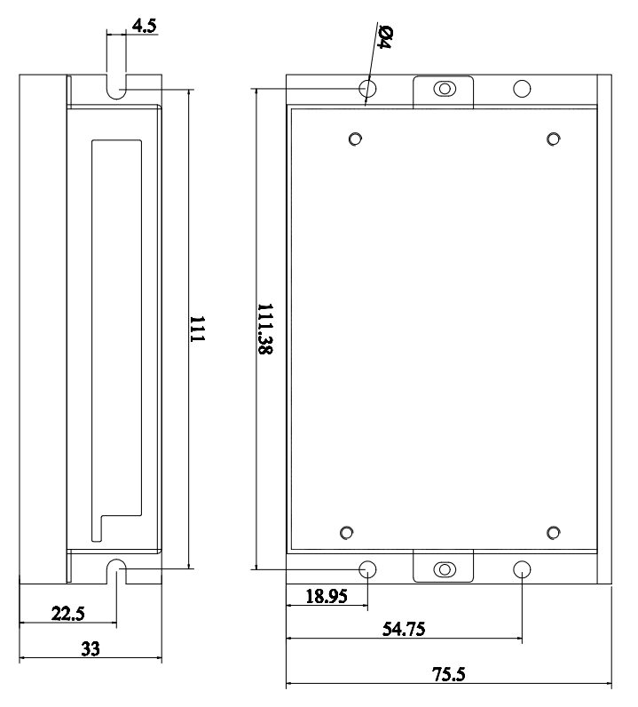
Figure 2.1 Installation dimensions (unit: mm)

2.2 Installation Notes
- The reliable operating temperature of the driver is usually within 50℃, and the operating temperature of the motor is within 80℃;
- It is recommended to select the automatic half-current mode when using, that is, when the motor stops, the current is automatically reduced by half to reduce the heating of the motor and driver;
- When installing the driver, please install it sideways and allow strong air convection to form on the bottom of the driver. If necessary, install a fan near the driver inside the machine to form air convection to assist in heat dissipation and ensure that the driver operates within a reliable operating temperature range.

2.3 Electrical specifications
illustrate | GRX04
illustrate | Minimum | Typical Value | Maximum | unit
Input power voltage | 18 | twenty four | 50 | VDC
Control signal input current | 7 | 10 | 16 | mA
Step pulse frequency | 0 | - | 200 | KHz
Insulation resistance | 50 |  |  | MΩ

2.4 Operating environment and parameters
Cooling method |  | Natural cooling, fan cooling
Usage Environment | occasion | Do not place it near other heating equipment. Avoid dust, oil mist, corrosive gas, high humidity and strong vibration. Flammable gas and conductive dust are prohibited.
Usage Environment | temperature | 0——50℃
Usage Environment | humidity | 40-90%RH
Usage Environment | vibration | 10~55Hz/0.15mm
Storage temperature |  | -20℃~65℃

Driver interface and wiring introduction

3.1SilkscreenSchematic diagram
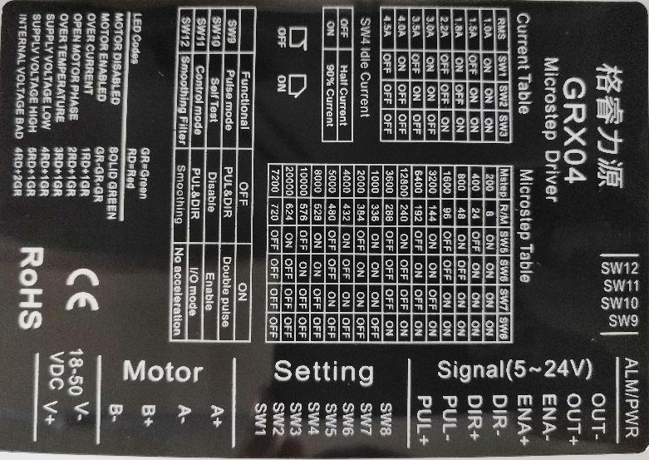
Figure 3.1 GRX04 Silk ScreenSchematic diagram

3.2 Interface Description
GRX04 Pulse Enhanced Open-Loop Stepper DriverPower supplyand motorInterface5.08-6PNeedle holder, signal control interface adopts3.81-8P pin header. For the specific definition of the interface, please refer to the following sections.

3.2.1 Control signal interface
name | Function
PUL+ | Pulse control signal: +5V-+24V can be driven, rising edge is effective, every time the pulse isLowChangehighThe motor takes one microstep. In order to reliably respond to the pulse signal, the pulse width should be greater than 2.5μs.
PUL-
DIR+ | Direction control signal: +5V-+24V can be driven, high/low level signal. To ensure reliable commutation of the motor, the direction signal should precede the pulse signal by at least 50μs established.
DIR-
ENA+ | Enable control signal: +5V-+24V can be driven, high/low level signal. Used to enable or disable the operation of the motor.A+Connect to +5V-+24V, ENA-When connected to a low level, the driver will cut off the current of each phase of the motor to make the motor in a free state, and the step pulse will not be responded to at this time. When this function is not needed, the enable signal terminal can be left floating. In addition, the EN terminal can also be used to clear the out-of-tolerance alarm signal.
ENA-

3.2.2 Output signal interface
The output signal interface defaults toBrake controlOutput function usage.
name | Function
OUT+ | Brake controlSignal output:When it happensOvercurrent,When overvoltage, undervoltage, or phase loss alarm occurs, the output signal is valid., control the brake;  For normally open or normally closed connection, see the description in Section 3.4;
OUT-

3.2.3Motor control output interface
name |  | color | illustrate | Function
Motor | A+ | red | Motor interface | Two-phase stepper motor wiring port, please pay attention to the line sequence;  If you want the opposite initial rotation direction, just swap A+ and A- or swap B+ and B-;
Motor | A- | blue | Motor interface
Motor | B+ | green | Motor interface
Motor | B- | black | Motor interface

3.2.4Power input interface
name |  | illustrate | Function
VDC | V+ | Power interface | Power Input  DC18V~50V
VDC | V- | Power interface | Power Input  DC18V~50V

3.2.5Status Indicator
GRX04 Pulse Enhanced Open-Loop Stepper DriverThe indicator light is a retracted SMD LED, and its basic definition is shown in the following table.
name | Function | illustrate
Green LED | power supply,runinstruct,  Alarm indicator light | When power is on normally,Green light is always on, red light is off;  During normal operation, the green light flashes and the red light is off;  When an abnormality occurs in the equipment, the red and green lights flash alternately to give an alarm.  For the flashing pattern, please refer to Chapter 6;
Red LED | power supply,runinstruct,  Alarm indicator light

3.3 Input control signal

3.3.1 Input control signal interface circuit
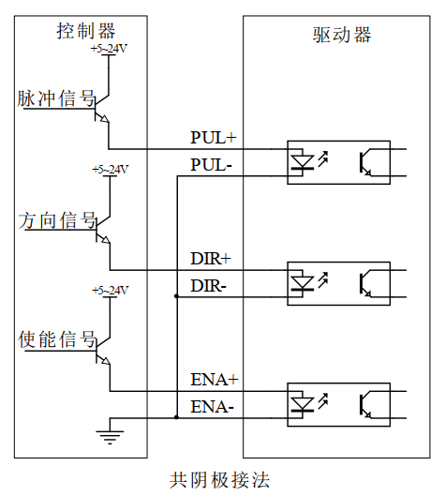
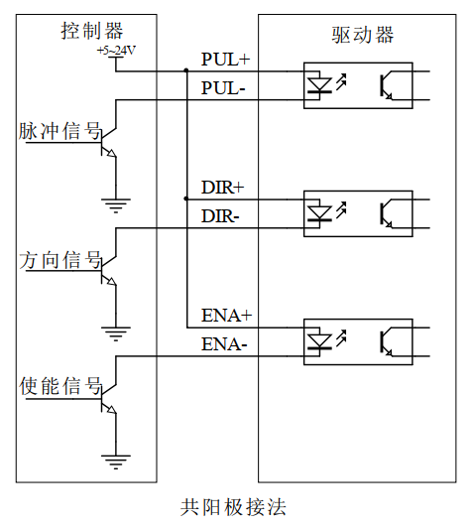
GRX04The driver control signal end adopts a differential interface circuit, which is applicable to differential signals, single-ended common cathode and common anode interfaces, and has a built-in high-speed photocoupler, which has strong anti-interference ability in harsh environments. The interface circuit diagram is shown in Figure 3.2.

Figure 3.2 Input interface circuit
▶Note:GRX04It is a 5V-24V universal driver, so the signal control end does not need a series resistor!

3.3.2 Control signal timing diagram
In order to avoid some misoperations and deviations, PUL, DIR and ENACertain requirements should be met, as shown in the following figure:
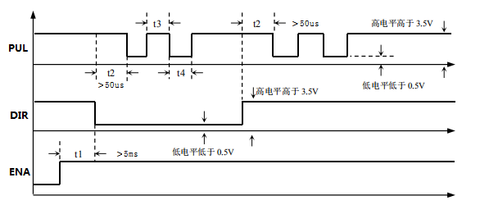

Figure 3.3 Control signal timing diagram
Notes:
- t1:ENA(Enable signal) should be advanced DIR is at least 5ms, determined to be high. Generally, it is recommended toA+ and ENA-Just leave it floating.
- t2:DIR at least in advance PULFalling edge 50μs determines its state high or low.
- t3: The pulse width is at least 2.5μs.
- t4: Low level width is not less than 2.5μs.

3.3.3 Control signal mode setting
Pulse trigger edge selection: The rising edge or falling edge of the pulse can be set to trigger effectively through the PC software.

3.4 Output control signal

3.4.1Used as brake control motor
GRX04The output port of the integrated open-loop stepper driver includes the control function of the brake motor brakeIf the user uses DC24V power supply, this output port can directly control the brake holding and releasing. If the user uses a power supply higher than DC24V, this output port cannot be used to control the brake directly, and you need to contact our technical staff for technical support.
The specific control process is as follows: When the driver is poweredThe effective state of the output interface is initially set to normally open output.At this time, the brake is in the engaged state. When the driver is powered on and stable, and the motor locks the shaft normally, it switches to the normally closed state and controls the brake to release. If during this period, the driver generates an overcurrent, over-voltage, undervoltage, or phase loss alarm, the brake will be engaged again..

3.5 Wiring requirements
- In order to prevent the driver from being interfered, it is recommended that the control signal use shielded cable, and the shield layer is short-circuited with the ground wire. Except for special requirements, the shield line of the control signal cable is grounded at one end: the host computer end of the shield line is grounded, and the driver end of the shield line is suspended. Only the same point is allowed to be grounded in the same machine. If it is not a real ground wire, there may be serious interference. In this case, the shield layer is not connected.
- The pulse and direction signal lines are not allowed to be wrapped side by side with the motor lines. It is best to separate them by at least 10 cm. Otherwise, the motor noise will easily interfere with the pulse direction signals and cause inaccurate motor positioning, system instability and other faults.
- If one power supply supplies multiple drives, they should be connected in parallel at the power supply. Chain connection from one drive to another is not allowed.
- It is strictly forbidden to plug or unplug the high-voltage terminals of the driver while it is powered on. When the motor is stopped, there is still a large current flowing through the coil. Plugging or unplugging the terminals while it is powered on will cause a huge instantaneous induced electromotive force that will burn out the driver.
- It is strictly forbidden to connect the wire end to the terminal after tinning it, otherwise the contact resistance may increase and the terminal may be damaged by overheating.
- The wiring ends must not be exposed outside the terminals to prevent accidental short circuits and damage to the driver.

DIP switch function setting
GRX04Driver8BitfrontDip switch+4-position side dip switch,Combined into 12-bit DIP switch control,SW1-SW3For current setting,SW4 is used for quiescent current setting,SW5-SW8For segmentation settings, SW9-SW12 is used for working mode settingThe detailed description is as follows:
SW1~SW3 | SW4 | SW5~SW8 | SW9~SW12
Current setting | Quiescent current setting | Segment settings | Working mode settings

4.1 Current Setting
SW1-SW3Set the output current of the driver. The DIP switches correspond to the default current settings, as shown in the table below.
SW1 | SW2 | SW3 | Peak(A) | RMS(A)
on | on | on | 1.4 | 1.0
off | on | on | 2.1 | 1.5
on | off | on | 2.5 | 1.8
off | off | on | 3.1 | 2.2
on | on | off | 4.2 | 3.0
off | on | off | 4.9 | 3.5
on | off | off | 5.6 | 4.0
off | off | off | 6.3 | 4.5

4.2 Quiescent Currentset up
The static current can be set with the SW4 DIP switch. Off means the static current is set to half of the dynamic current, and on means the static current is set to 90% of the dynamic current. In general use, SW4 should be set to off to reduce the heat generation of the motor and driver and improve reliability. After the pulse input stops, the current is automatically reduced to half.

4.3Segment settings
SW5-SW8Set the subdivision of the driver. There are 16 subdivisions that can be set. The dial corresponds to the default subdivision settings, as shown in the following table:
Steps/turn | RPM | SW5 | SW6 | SW7 | SW8
200 | 8 | on | on | on | on
400 | twenty four | off | on | on | on
800 | 48 | on | off | on | on
1600 | 96 | off | off | on | on
3200 | 144 | on | on | off | on
6400 | 192 | off | on | off | on
12800 | 240 | on | off | off | on
3600 | 288 | off | off | off | on
1000 | 336 | on | on | on | off
2000 | 384 | off | on | on | off
4000 | 432 | on | off | on | off
5000 | 480 | off | off | on | off
8000 | 528 | on | on | off | off
10000 | 576 | off | on | off | off
20000 | 624 | on | off | off | off
7200 | 720 | off | off | off | off

4.4 Working Modeset up
SW9-SW12Setting the driveWorking Mode,specificAs shown in the following table:
 | off | on | Functional Description
SW9 | Pulse+direction | Double Pulse | In pulse mode, select single and double pulse function
SW10 | prohibit | Enable | Self-test mode function, if enabled, the drive will enter self-test mode when powered on, rotate forward 90°, reverse 90°, and run in a cycle
SW11 | Pulse Mode | I/O Mode | Set the drive to work in pulse mode or I/O control mode
SW12 | With smoothing | Without smoothing | Set whether the drive runs with smoothing

Power supply selection
The power supply voltage can work normally within the specified range.GRX04The driver is best powered by a regulated DC switching power supply, and it should be noted that the output current range of the switching power supply must be set to the maximum. An unregulated DC power supply can also be used, but it should be noted that the peak value of the voltage ripple after rectification should not exceed the maximum voltage specified. It is recommended that users use a DC voltage lower than the maximum voltage to avoid grid fluctuations exceeding the driver voltage operating range.
▶Note:
- When wiring, pay attention to the positive and negative poles of the power supply and do not connect them in reverse;
- When wiring, pay attention to the position of the power interface and do not connect it to the motor port. After connecting, it is best to confirm whether it is connected correctly;
- It is best to use a regulated DC switching power supply;
- When using an unregulated DC power supply, the power supply current output capacity should be greater than 60% of the driver set current;
- When using a regulated DC switching power supply, the output current of the power supply should be greater than or equal to the operating current of the driver;
- To reduce costs, two or three drivers can share one power supply, but the power supply must be large enough.

Indicator lights and alarm indicators
GRX04 Pulse Enhanced Open-Loop Stepper DriverThere is a green LED and a red LED, one of which can be used as a power indicator, operation indicator light,The second one can be used as a fault indicator light. The specific relationship is shown in Table 6.1 below:
When the driver is powered on, the green LED is always on, and when the driver is powered off, the green LED is off.
When the driver receives the pulse signal and controls the motor to operate normally, the green light flashes continuously and the red light remains off.
When the drive fails, the red and green lights flash alternately, and different flashing patterns indicate different fault information. When the fault is eliminated by the user, the green LED remains on and the red LED goes out.
Table 6.1 LED status indication
Number of LED flashes |  | Phenomenon | illustrate
Green LED | Red LED | Green light flashing or red and green lights alternatingFlash
0 | - | Green light is always on, red light is off | Driver Enableor not enabled
1 | - | Green light flashes, red light off | Receive pulse signal, the motor is running
1 | 1 |  | Overcurrent alarm
1 | 2 |  | Phase loss alarm
1 | 3 |  | Over temperature alarm (reserved)
1 | 4 |  | Overpressure alarm
1 | 5 |  | Undervoltage alarm
2 | 4 |  | Internal voltage error alarm (reserved)

Warranty and after-sales

7.1 Warranty

7.1.1 Free warranty
Our company solemnly promises that if any of our products are damaged during use due to the product itself, we will provideOne yearFree repair service. The shipping cost of the product shall be borne by both parties.

7.1.2 Warranty exclusion
- The driver is damaged due to the customer's own wiring error;
- The drive is damaged due to exceeding the rated working voltage;
- The DC power supply driver is connected to the AC power supply, causing the driver to be damaged;
- The driver is damaged due to the customer's extremely harsh on-site environment, such as humidity, extreme cold, extreme heat, etc., without informing our company in advance;
- The customer dismantles the drive housing without permission or the serial label number is torn off;
- 15 days after the customer confirms receipt, the housing is obviously damaged or hit, resulting in damage to the drive;
- Forceful natural disasters, such as fire, earthquake, tsunami, typhoon, etc.;
In the above cases, our company will charge a certain amount of repair cost after evaluating the interests of all parties. In other cases, repairs will be provided free of charge forever.

7.2 Exchange

7.2.1 Replacement of defective product
For faults in new products, our company provides three months of free replacement service.
After our technical support staff confirms that the problem is with the product itself, they will send the product back to our company to avoid wasting time and postage on the round trip. Customers need to send the faulty product back by express or logistics first, and our company will send another new product back to the customer as soon as possible after receiving it.
Notice:All our products undergo rigorous testing and aging before leaving the warehouse, so it is extremely rare for new products to malfunction. Please be sure to read the instructions carefully or consult our technical support staff when operating, or our technical support staff will remotely assist customers in operating.
- Please note the following points when exchanging goods:
(1) Please ensure that the package is complete when sending it back to avoid damage during transportation;
(2) Please ensure that the attached accessories are complete when exchanging the product;
(3) Each driver should be packaged independently in its original outer box to avoid secondary damage to the product during transportation;
(4) If the driver is returned and it is confirmed that the fault is not due to product failure, but rather due to the customer's negligence in operation, which led to the customer mistakenly thinking that the driver is faulty, the company will not bear the shipping costs (the customer's negligence in operation includes: the driver is damaged due to wrong wiring, the driver is mistakenly thought to be damaged due to poor wiring, the driver cannot be used normally due to operation errors, etc.).

7.2.2 Exchange for non-product failure
If the customer is not satisfied with the appearance or function of the product received and wants to replace it with a better driver, he or she can apply for a replacement service from our company within one week of receiving the product. After verification, our company will return the product. If the returned product is confirmed to be undamaged, with complete accessories and good packaging, the company will replace it with another product for the customer. For the replaced product, if there is a price difference, the customer will make up the difference.
Note: The replaced product will no longer be eligible for the non-product fault replacement service. The round-trip shipping costs and other costs incurred by the non-product fault replacement service shall be borne by the customer!

7.3 Returns
Our company provides a 7-day return service for products with quality problems. If you find quality problems with the product within 7 days of receiving the product (based on the actual date of receipt by the customer), please communicate with our salesperson or technical support personnel in time. After our technical support personnel confirms that it is a quality problem of the company's product itself, the customer can send the original complete product and its inner and outer packaging, accessories and shipping order back to our company by express or logistics.
If the customer still insists on returning the goods after our company has checked and confirmed that they are correct, the round-trip shipping costs and all other costs incurred shall be borne by the customer.
- Please note the following points when returning goods:
(1) Please contact the relevant department of our company before making a refund;
(2) The product must be in new condition and intact packaging. Please send it back to our company by express or logistics;
(3) We will not accept any complaints caused by customers, such as product appearance damage, incomplete accessories, etc.

7.4 After-sales service
If customers encounter technical problems when using this product, please contact our company as soon as possible. Please call our national free service hotline: 0755-23206995.
Service hours: 8:30-17:30, Monday to Friday (except national holidays).

Revision History
Version Number | illustrate | Modify deadline | Preparer/Reviewer
V1.0.0 | Initial use version; | 2022..08.10 | TCJ/XH

